Batch: A2 Roll No.: 16010322014
Experiment / assignment / tutorial No. 8
Grade: AA / AB / BB / BC / CC / CD /DD
Signature of the Staff In-charge with date

Title: Configuring Basic EIGRP for IPv4

Objectives:
Part 1: Build the Network and Verify Connectivity
Part 2: Configure EIGRP Routing
Part 3: Verify EIGRP Routing
Part 4: Configure Bandwidth and Passive Interfaces

OUTCOME:
CO 4. Implement Enhanced Interior Gateway Routing Protocol (EIGRP)

Tools required:
Packet Tracer software

Theory:
Enhanced Interior Gateway Routing Protocol (EIGRP) is a powerful distance vector routing protocol and is relatively easy to configure for basic networks.
Configure EIGRP for the topology and networks shown above. Modify bandwidth and configure passive interfaces to allow EIGRP to function more efficiently..

Task:

Topology 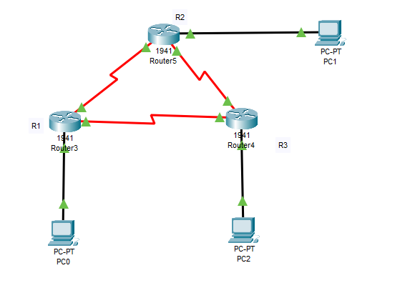
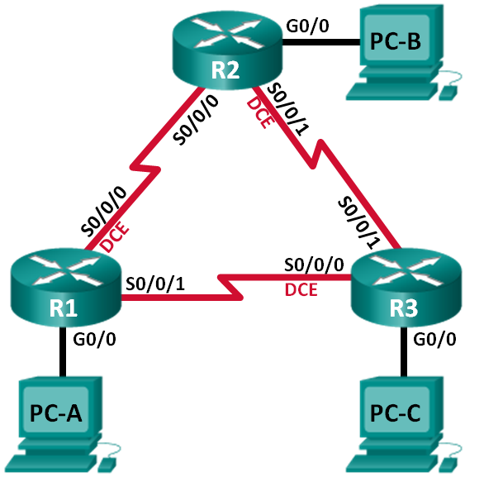

Addressing Table
Device | Interface | IP Address | Subnet Mask | Default Gateway
R1 | G0/0 | 192.168.1.1 | 255.255.255.0 | N/A
 | S0/0/0 (DCE) | 10.1.1.1 | 255.255.255.252 | N/A
 | S0/0/1 | 10.3.3.1 | 255.255.255.252 | N/A
R2 | G0/0 | 192.168.2.1 | 255.255.255.0 | N/A
 | S0/0/0 | 10.1.1.2 | 255.255.255.252 | N/A
 | S0/0/1 (DCE) | 10.2.2.2 | 255.255.255.252 | N/A
R3 | G0/0 | 192.168.3.1 | 255.255.255.0 | N/A
 | S0/0/0 (DCE) | 10.3.3.2 | 255.255.255.252 | N/A
 | S0/0/1 | 10.2.2.1 | 255.255.255.252 | N/A
PC-A | NIC | 192.168.1.3 | 255.255.255.0 | 192.168.1.1
PC-B | NIC | 192.168.2.3 | 255.255.255.0 | 192.168.2.1
PC-C | NIC | 192.168.3.3 | 255.255.255.0 | 192.168.3.1

- Build the Network and Verify Connectivity
In Part 1, you will set up the network topology and configure basic settings, such as the interface IP addresses, device access, and passwords.
  - Cable the network as shown in the topology.
  - Configure PC hosts.
  - Initialize and reload the routers as necessary.
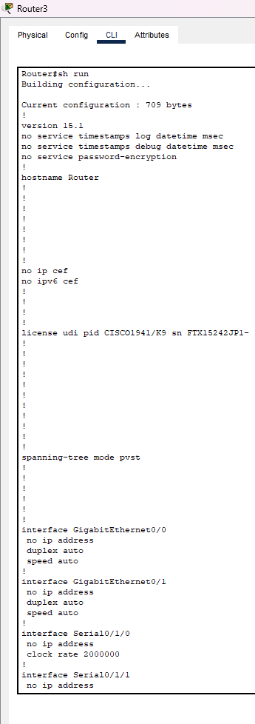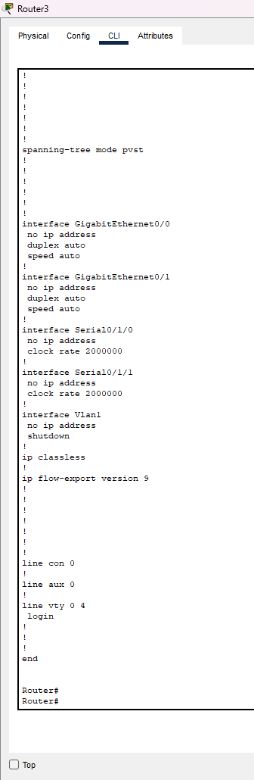

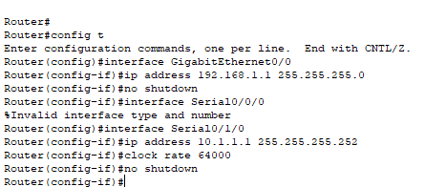
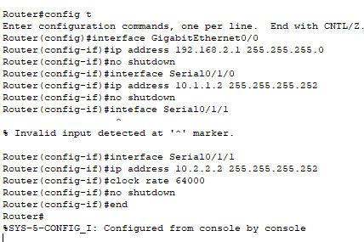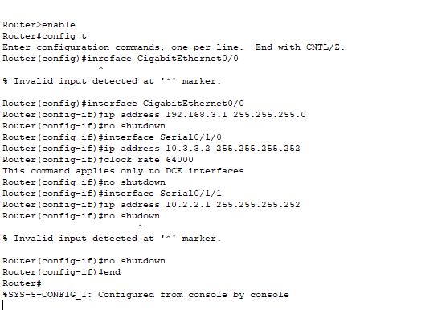
  - Configure basic settings for each router.
    - Disable DNS lookup.
    - Configure IP addresses for the routers, as listed in the Addressing Table.
    - Configure device name as shown in the topology.
    - Assign cisco as the console and vty passwords.
    - Assign class as the privileged EXEC password.
    - Configure logging synchronous to prevent console and vty messages from interrupting command entry.
    - Configure a message of the day.
    - Copy the running configuration to the startup configuration.
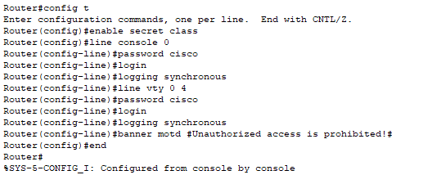
  - Verify connectivity.
The routers should be able to ping one another, and each PC should be able to ping its default gateway. The PCs will not be able to ping other PCs until EIGRP routing is configured. Verify and troubleshoot if necessary.
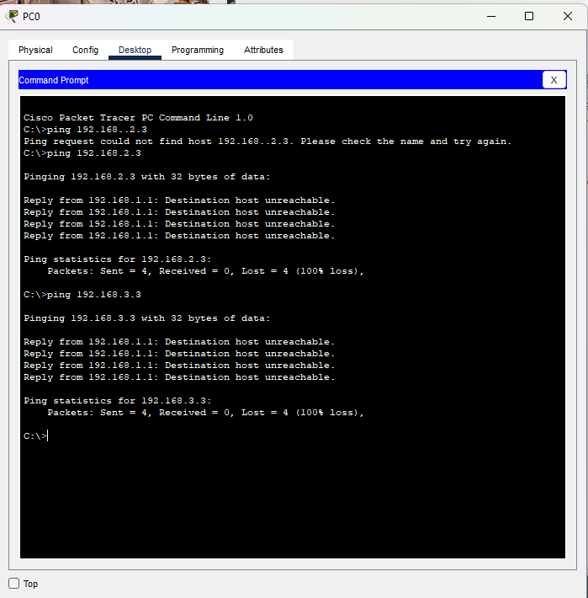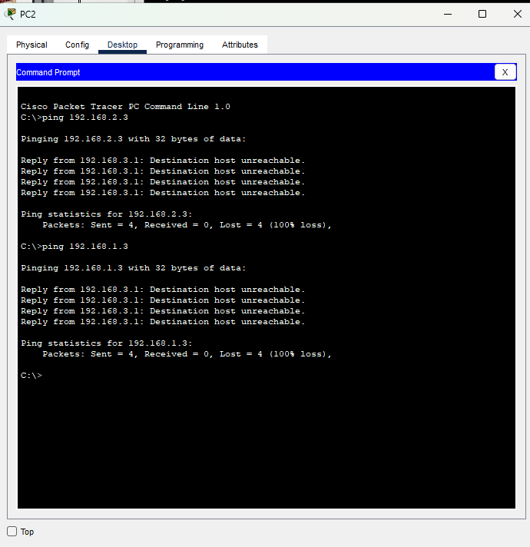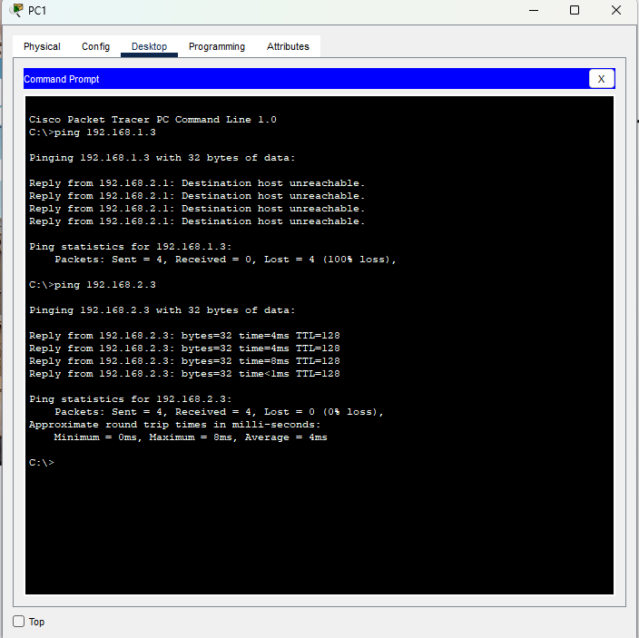
- Configure EIGRP Routing
  - Enable EIGRP routing on R1. Use AS number 10.
R1(config)# router eigrp 10
  - Advertise the directly connected networks on R1 using the wildcard mask.
R1(config-router)# network 10.1.1.0 0.0.0.3
R1(config-router)# network 192.168.1.0 0.0.0.255
R1(config-router)# network 10.3.3.0 0.0.0.3
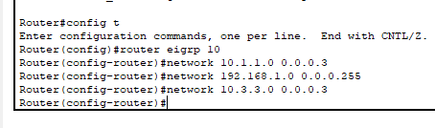
Why is it a good practice to use wildcard masks when advertising networks? Could the mask have been omitted from any of the network statements above? If so, which one(s)?
You should only advertise networks that you control. In earlier versions of EIGRP, classful boundaries were assumed meaning that the whole network space was advertised. For example, when advertising the 10.1.1.0 network, the 10.0.0.0/8 could be assumed. The wildcard mask could have been omitted from the 192.168.1.0 network statement because EIGRP would automatically assume the 0.0.0.255 classful mask.
  - Enable EIGRP routing and advertise the directly connected networks on R2 and R3.
You will see neighbor adjacency messages as interfaces are added to the EIGRP routing process. The messages on R2 are displayed as an example.
*Apr 14 15:24:59.543: %DUAL-5-NBRCHANGE: EIGRP-IPv4 10: Neighbor 10.1.1.1 (Serial0/0/0) is up: new adjacency
  - Verify end-to-end connectivity.
All devices should be able to ping each other if EIGRP is configured correctly.
Note: Depending on the operating system, it may be necessary to disable the firewall for the pings to the host PCs to be successful.
- Verify EIGRP Routing
  - Examine the EIGRP neighbor table.
On R1, issue the show ip eigrp neighbors command to verify that the adjacency has been established with its neighboring routers.
R1# show ip eigrp neighbors
EIGRP-IPv4 Neighbors for AS(10)
H Address Interface Hold Uptime SRTT RTO Q Seq
(sec) (ms) Cnt Num
1 10.3.3.2 Se0/0/1 13 00:24:58 8 100 0 17
0 10.1.1.2 Se0/0/0 13 00:29:23 7 100 0 23
  - Examine the IP EIGRP routing table.
R1# show ip route eigrp
Codes: L - local, C - connected, S - static, R - RIP, M - mobile, B - BGP
D - EIGRP, EX - EIGRP external, O - OSPF, IA - OSPF inter area
N1 - OSPF NSSA external type 1, N2 - OSPF NSSA external type 2
E1 - OSPF external type 1, E2 - OSPF external type 2
i - IS-IS, su - IS-IS summary, L1 - IS-IS level-1, L2 - IS-IS level-2
ia - IS-IS inter area, * - candidate default, U - per-user static route
o - ODR, P - periodic downloaded static route, H - NHRP, l - LISP
+ - replicated route, % - next hop override

Gateway of last resort is not set

10.0.0.0/8 is variably subnetted, 5 subnets, 2 masks
D 10.2.2.0/30 [90/2681856] via 10.3.3.2, 00:29:01, Serial0/0/1
[90/2681856] via 10.1.1.2, 00:29:01, Serial0/0/0
D 192.168.2.0/24 [90/2172416] via 10.1.1.2, 00:29:01, Serial0/0/0
D 192.168.3.0/24 [90/2172416] via 10.3.3.2, 00:27:56, Serial0/0/1
Why does R1 have two paths to the 10.2.2.0/30 network?
EIGRP automatically does equal-cost load balancing. R1 has two ways to reach the 10.2.2.0/30 network.

  - Examine the EIGRP topology table.
R1# show ip eigrp topology
EIGRP-IPv4 Topology Table for AS(10)/ID(192.168.1.1)
Codes: P - Passive, A - Active, U - Update, Q - Query, R - Reply,
r - reply Status, s - sia Status

P 192.168.3.0/24, 1 successors, FD is 2172416
via 10.3.3.2 (2172416/28160), Serial0/0/1
P 192.168.2.0/24, 1 successors, FD is 2172416
via 10.1.1.2 (2172416/28160), Serial0/0/0
P 10.2.2.0/30, 2 successors, FD is 2681856
via 10.1.1.2 (2681856/2169856), Serial0/0/0
via 10.3.3.2 (2681856/2169856), Serial0/0/1
P 10.3.3.0/30, 1 successors, FD is 2169856
via Connected, Serial0/0/1
P 192.168.1.0/24, 1 successors, FD is 2816
via Connected, GigabitEthernet0/0
P 10.1.1.0/30, 1 successors, FD is 2169856
via Connected, Serial0/0/0
Why are there no feasible successors listed in the R1 topology table?
The feasibility condition (FC) has not been met.

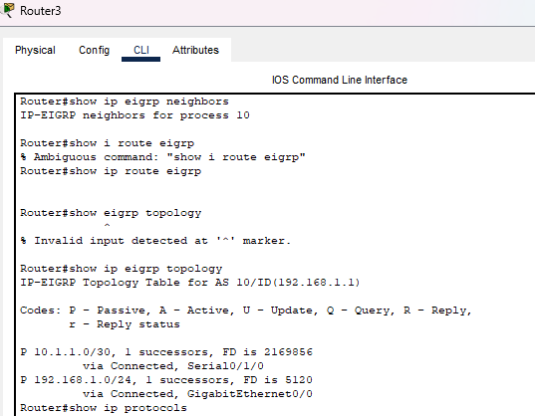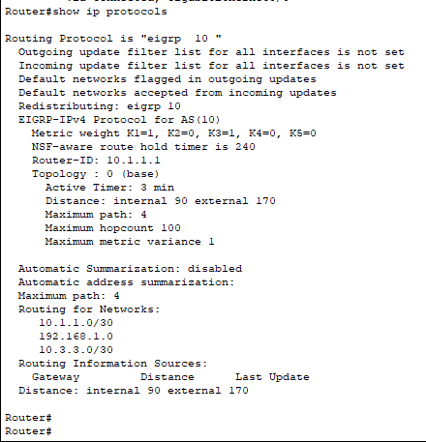
  - Verify the EIGRP routing parameters and networks advertised.
Issue the show ip protocols command to verify the EIGRP routing parameters used.
R1# show ip protocols
*** IP Routing is NSF aware ***

Routing Protocol is "eigrp 10"
Outgoing update filter list for all interfaces is not set
Incoming update filter list for all interfaces is not set
Default networks flagged in outgoing updates
Default networks accepted from incoming updates
EIGRP-IPv4 Protocol for AS(10)
Metric weight K1=1, K2=0, K3=1, K4=0, K5=0
NSF-aware route hold timer is 240
Router-ID: 192.168.1.1
Topology : 0 (base)
Active Timer: 3 min
Distance: internal 90 external 170
Maximum path: 4
Maximum hopcount 100
Maximum metric variance 1

Automatic Summarization: disabled
Maximum path: 4
Routing for Networks:
10.1.1.0/30
10.3.3.0/30
192.168.1.0
Routing Information Sources:
Gateway Distance Last Update
10.3.3.2 90 02:38:34
10.1.1.2 90 02:38:34
Distance: internal 90 external 170
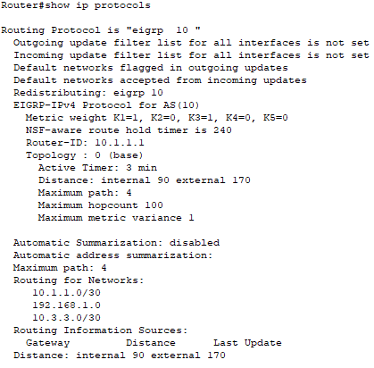
Based on the output of issuing the show ip protocols command, answer the following questions.
What AS number is used? ___10______
What networks are advertised? 10.1.1.0/30, 10.3.3.0/30, and 192.168.1.0/24
What is the administrative distance for EIGRP? __ 90 internal and 170 external___________________________
How many equal cost paths does EIGRP use by default? _____4____
- Configure Bandwidth and Passive Interfaces
EIGRP uses a default bandwidth based on the type of interface in the router. In Part 4, you will modify the bandwidth so that the link between R1 and R3 has a lower bandwidth than the link between R1/R2 and R2/R3. In addition, you will set passive interfaces on each router.
  - Observe the current routing settings.
    - Issue the show interface s0/0/0 command on R1.
R1# show interface s0/0/0
Serial0/0/0 is up, line protocol is up
Hardware is WIC MBRD Serial
Internet address is 10.1.1.1/30
MTU 1500 bytes, BW 1544 Kbit/sec, DLY 20000 usec,
reliability 255/255, txload 1/255, rxload 1/255
Encapsulation HDLC, loopback not set
Keepalive set (10 sec)
Last input 00:00:01, output 00:00:02, output hang never
Last clearing of "show interface" counters 03:43:45
Input queue: 0/75/0/0 (size/max/drops/flushes); Total output drops: 0
Queueing strategy: fifo
Output queue: 0/40 (size/max)
5 minute input rate 0 bits/sec, 0 packets/sec
5 minute output rate 0 bits/sec, 0 packets/sec
4050 packets input, 270294 bytes, 0 no buffer
Received 1554 broadcasts (0 IP multicasts)
0 runts, 0 giants, 0 throttles
1 input errors, 0 CRC, 0 frame, 0 overrun, 0 ignored, 1 abort
4044 packets output, 271278 bytes, 0 underruns
0 output errors, 0 collisions, 5 interface resets
4 unknown protocol drops
0 output buffer failures, 0 output buffers swapped out
12 carrier transitions
DCD=up DSR=up DTR=up RTS=up CTS=up
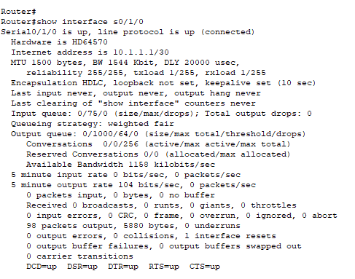
What is the default bandwidth for this serial interface? _______________________________1544_________
    - How many routes are listed in the routing table to reach the 10.2.2.0/30 network? __________2_____
  - Modify the bandwidth on the routers.
    - Modify the bandwidth on R1 for the serial interfaces.
R1(config)# interface s0/0/0
R1(config-if)# bandwidth 2000
R1(config-if)# interface s0/0/1
R1(config-if)# bandwidth 64
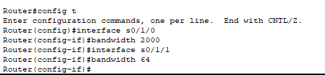
Issue show ip route command on R1. Is there a difference in the routing table? If so, what is it?
Codes: L - local, C - connected, S - static, R - RIP, M - mobile, B - BGP
D - EIGRP, EX - EIGRP external, O - OSPF, IA - OSPF inter area
N1 - OSPF NSSA external type 1, N2 - OSPF NSSA external type 2
E1 - OSPF external type 1, E2 - OSPF external type 2
i - IS-IS, su - IS-IS summary, L1 - IS-IS level-1, L2 - IS-IS level-2
ia - IS-IS inter area, * - candidate default, U - per-user static route
o - ODR, P - periodic downloaded static route, H - NHRP, l - LISP
+ - replicated route, % - next hop override

Gateway of last resort is not set

10.0.0.0/8 is variably subnetted, 5 subnets, 2 masks
C 10.1.1.0/30 is directly connected, Serial0/0/0
L 10.1.1.1/32 is directly connected, Serial0/0/0
D 10.2.2.0/30 [90/2681856] via 10.1.1.2, 00:03:09, Serial0/0/0
C 10.3.3.0/30 is directly connected, Serial0/0/1
L 10.3.3.1/32 is directly connected, Serial0/0/1
192.168.1.0/24 is variably subnetted, 2 subnets, 2 masks
C 192.168.1.0/24 is directly connected, GigabitEthernet0/0
L 192.168.1.1/32 is directly connected, GigabitEthernet0/0
D 192.168.2.0/24 [90/1794560] via 10.1.1.2, 00:03:09, Serial0/0/0
D 192.168.3.0/24 [90/2684416] via 10.1.1.2, 00:03:08, Serial0/0/0
After the change in bandwidth, there is only one route showing for the 10.2.2.0/30 network via 10.1.1.2 and S0/0/0. This is the preferred link because it is a faster link. Before the change in bandwidth, there were two equal cost paths to the destination; therefore, there were two entries in the routing table

Modify the bandwidth on the R2 and R3 serial interfaces.
R2(config)# interface s0/0/0
R2(config-if)# bandwidth 2000
R2(config-if)# interface s0/0/1
R2(config-if)# bandwidth 2000

R3(config)# interface s0/0/0
R3(config-if)# bandwidth 64
R3(config-if)# interface s0/0/1
R3(config-if)# bandwidth 2000
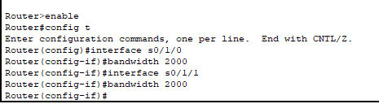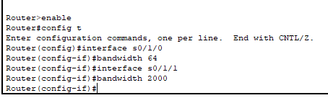
  - Verify the bandwidth modifications.
    - Verify bandwidth modifications. Issue a show interface serial 0/0/x command, with x being the appropriate serial interface on all three routers to verify that bandwidth is set correctly. R1 is shown as an example.
R1# show interface s0/0/0
Serial0/0/0 is up, line protocol is up
Hardware is WIC MBRD Serial
Internet address is 10.1.1.1/30
MTU 1500 bytes, BW 2000 Kbit/sec, DLY 20000 usec,
reliability 255/255, txload 1/255, rxload 1/255
Encapsulation HDLC, loopback not set
Keepalive set (10 sec)
Last input 00:00:01, output 00:00:02, output hang never
Last clearing of "show interface" counters 04:06:06
Input queue: 0/75/0/0 (size/max/drops/flushes); Total output drops: 0
Queueing strategy: fifo
Output queue: 0/40 (size/max)
5 minute input rate 0 bits/sec, 0 packets/sec
5 minute output rate 0 bits/sec, 0 packets/sec
4767 packets input, 317155 bytes, 0 no buffer
Received 1713 broadcasts (0 IP multicasts)
0 runts, 0 giants, 0 throttles
1 input errors, 0 CRC, 0 frame, 0 overrun, 0 ignored, 1 abort
4825 packets output, 316451 bytes, 0 underruns
0 output errors, 0 collisions, 5 interface resets
4 unknown protocol drops
0 output buffer failures, 0 output buffers swapped out
12 carrier transitions
DCD=up DSR=up DTR=up RTS=up CTS=up
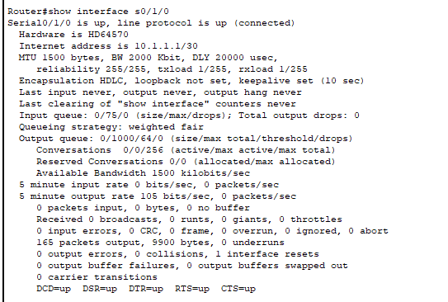
Based on your bandwidth configuration, try and determine what the R2 and R3 routing tables will look like before you issue a show ip route command. Are their routing tables the same or different?
R2 routing table will be the same as before. It will still have 2 equal cost routes to the 10.3.3.0/30 network. R3 routing table will now only have 1 route to the 10.1.1.0/30 network via R2.
  - Configure G0/0 interface as passive on R1, R2, and R3.
A passive interface does not allow outgoing and incoming routing updates over the configured interface. The passive-interface interface command causes the router to stop sending and receiving Hello packets over an interface; however, the network associated with the interface is still advertised to other routers through the non-passive interfaces. Router interfaces connected to LANs are typically configured as passive.
R1(config)# router eigrp 10
R1(config-router)# passive-interface g0/0

R2(config)# router eigrp 10
R2(config-router)# passive-interface g0/0

R3(config)# router eigrp 10
R3(config-router)# passive-interface g0/0
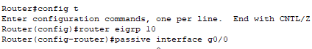
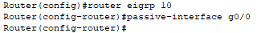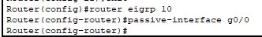
  - Verify the passive interface configuration.
Issue a show ip protocols command on R1, R2, and R3 and verify that G0/0 has been configured as passive.
R1# show ip protocols
*** IP Routing is NSF aware ***

Routing Protocol is "eigrp 10"
Outgoing update filter list for all interfaces is not set
Incoming update filter list for all interfaces is not set
Default networks flagged in outgoing updates
Default networks accepted from incoming updates
EIGRP-IPv4 Protocol for AS(10)
Metric weight K1=1, K2=0, K3=1, K4=0, K5=0
NSF-aware route hold timer is 240
Router-ID: 192.168.1.1
Topology : 0 (base)
Active Timer: 3 min
Distance: internal 90 external 170
Maximum path: 4
Maximum hopcount 100
Maximum metric variance 1

Automatic Summarization: disabled
Maximum path: 4
Routing for Networks:
10.1.1.0/30
10.3.3.0/30
192.168.1.0
Passive Interface(s):
GigabitEthernet0/0
Routing Information Sources:
Gateway Distance Last Update
10.3.3.2 90 00:48:09
10.1.1.2 90 00:48:26
Distance: internal 90 external 170
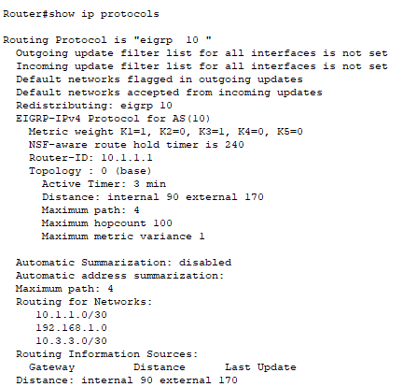
Reflection
You could have used only static routing for this lab. What is an advantage of using EIGRP?
EIGRP can automatically adjust for network topology changes such as adding networks, or networks going down. EIGRP automatically picks the best path when the bandwidth of a link is modified, and it will automatically load balance across multiple equal cost paths.
Router Interface Summary Table
Router Interface Summary
Router Model | Ethernet Interface #1 | Ethernet Interface #2 | Serial Interface #1 | Serial Interface #2
1800 | Fast Ethernet 0/0 (F0/0) | Fast Ethernet 0/1 (F0/1) | Serial 0/0/0 (S0/0/0) | Serial 0/0/1 (S0/0/1)
1900 | Gigabit Ethernet 0/0 (G0/0) | Gigabit Ethernet 0/1 (G0/1) | Serial 0/0/0 (S0/0/0) | Serial 0/0/1 (S0/0/1)
2801 | Fast Ethernet 0/0 (F0/0) | Fast Ethernet 0/1 (F0/1) | Serial 0/1/0 (S0/1/0) | Serial 0/1/1 (S0/1/1)
2811 | Fast Ethernet 0/0 (F0/0) | Fast Ethernet 0/1 (F0/1) | Serial 0/0/0 (S0/0/0) | Serial 0/0/1 (S0/0/1)
2900 | Gigabit Ethernet 0/0 (G0/0) | Gigabit Ethernet 0/1 (G0/1) | Serial 0/0/0 (S0/0/0) | Serial 0/0/1 (S0/0/1)

Signature of faculty in-charge

